Section and Group number/Project name here

CS 174 Final Project

Johan Hestenes, Avi Dey, Robert Lee, Thomas Croft

December 16, 2014

CS 174

Group 7

Section 1

(Final) Milestone 2

# Table of Contents

Contents

Table of Contents 2

Individual Contribution Summary 6

Introduction 7

New skills learned and applied to this project 8

Website Deployment 9

Data preparation and description 10

Data validation 10

Database Tables Details 12

Integrating 10 martial arts sql files into one 14

Cleaning and labeling of data 17

Edited Movies 17

Video data input and modification 19

• First, Login with an admin account 19

Login/Registration 22

Registration password check 22

Login and logout 24

Show the workflow with narrated screenshots on your login and logout process here.Above is the homepage with a user account with proper credentials 24

Startup page 27

Favorite/recommended videos 29

Video search 30

The values of the select boxes are numeric, however each are named after the type field that will limit the search. The numeric values are used as keys to map to the specific values shown. For example, the select box for Video Length has values 0-5min, 5-10min, 10-30min, 30-60min and 60+. These are matched in term to 0, 1, 2, 3, 4. These are then matched to an array that looks like this 30

Browse by selected category 31

Favorite videos 32

Selecting favorite videos 32

Testing with web browsers 34

Bonus Feature 36

Chinese Kung Fu Movie Youtube videos 36

**4. Best Action Movies | Nicholas Tse Full HD Movies English Subtitles | Chinese Martial Art (Treasure Inn)** 36

**5.  Best Action Movies | Donnie Yen | The Lost Bladesman HD English Subtitles(The Lost Bladesman)** 37

**6. ACTION MOVIES 2014 - DONNIE YEN | THE SW0RDSMEN 3D - BEST KUNGFU FULL HD English Subtitle(Dragon - Wu Xia)** 37

Checklist (UnCheck those that were not FULLY completed)

|  |  |
| --- | --- |
| X | **A.    Data correction and preparation** |
| X | A.1 Follow the fun\_video\_all.sql format to integrate 10 given martial arts sql files into one. |
| X | A.2 Remove videos not satisfying the needs |
| X | A.3 Correct any discrepancy in videos. |
| X | A.4 Correct and/or add tags to better characterize videos |
| X | A.5 Provide script(s) to allow users to retrieve and correct video information |
| X | **B.    Login/Registration module** |
| X | B.1 Add a registration that takes on user id (email) and password |
| X | B.2 An authentication (login) page to allow registered users to login. |
| X | B.3 Password check has to be enforced to ensure a minimal of 8 characters and at least one number and one letter are in the password entered. |
| X | B.4 Upon login, users should be directed to a webpage with his/her favorite videos as well as links to change profile and password. |
| X | B.5 Upon logout, users should be brought back to the startup page as described in C. |
| X | **C.   Startup page requirement** |
| X | C.1 A slideshow of selected martial arts video that show the highlighted of the action and lasts for 10-15 seconds each. The entire screen must be filled with the slideshow similar to [http://www.sjsu-cs.org/classes/cs174/bonushw/funvideo/view.php (Links to an external site.)](http://www.sjsu-cs.org/classes/cs174/bonushw/funvideo/view.php" \t "_blank) |
| X | C.2 All menu links to other features should be listed on top or left. |
| X | C.3 Randomly selected or rotating 3-5 recommended videos should be displayed below the slideshow as a row of icon images. Upon selection, the selected recommended video should be played in sizes no smaller than that of youtube default play console dimension. |
| X | C.4 Provide a search box that allows users to use keywords to locate related videos. It should be located near the bottom or the top of the slideshow console. |
|  | C.5 Allow users to find videos matching an AND combination of different selected parameters on highest resolution, view count, video length, language, video type, and martial arts category. The matching videos should be return in a format described in C.6. |
| X | C.6 Show 10 or fewer videos per page for matching videos. Use pagination to allow users to navigate to the rest of the videos. |
| X | **D.   Favorite videos** |
| X | D.1    For videos shown to the user, allow user to select and mark them as a favorite video. |
| X | D.2   Session should be used for this personalized feature. It should require login so different user can have different favorite video list |
|  | D.3   Display 3-4 favorite videos on user’s homepage upon login as describe in C.3. Each of the favorite video icon image should open up and play the Youtube video in youtube playback console dimension or bigger upon selection. |
| X | D.4 Allow logged in users to view and unselect all his/her favorite videos. |
| X | **E.     Server-side script hosting** |
| X | E.1 Host your final work under http://www.sjsu-cs.org/classes/cs174/sec2/lastname/milestone2/  (or sec2) Do not create subfolder to host your code under the give link. Simply put your code directly under the milestone2 folder. |
| X | E.2 Your startup page should be http://www.sjsu-cs.org/classes/cs174/sec2/lastname/milestone2/  (or sec2). In other words, use index.html or index.php as your startup webpage. |
| X | E.3 Your work has to run well under Chrome and Firefox in the websites assigned by the instructor as shown in B.1. Features that require PhP version newer than 5.4 should not be attempted. |
| X | **F. Compose technical reports and participate effectively in technical discussions** |
| X | F.1: Provide a technical report by following the report template, under your CANVAS ACCOUNT ->Modules->HW and Team Project. |
| X | **G. Peer evaluation**: Upload confidential evaluation form to your CANVAS account and provide web-based peer evaluation for your team members. |
| X | H. Provide a checklist exactly as shown on first page of the sample report that lists all technical requirements A-H and check off only those that are fully accomplished (double penalty for false claims). |
| X | **Bonus (if attempted and how many movies were entered) – 5 movies** |

# Individual Contribution Summary

|  |  |  |
| --- | --- | --- |
| Student Name | Technical part | Report drafting |
| Tom Croft | · Favorite Videos  · Pagination  · Uploaded and integrated | ·  Account information  ·  Deployment |
| Avi Dey | · Full screen video slideshow on homepage  · Display suggested videos on homepage | · Introduction  · New Skills Learned  · Login/ Registration |
| Robert Lee | ·  Data correction and integration · CSS Styling · Show favorite videos on index.php · Added Search | ·  Data preparation and cleaning  ·  New edit format |
| Johan Hestenes | ·  Added edit profile button for registered users  ·  User can change his/her email and password  ·  Grouped important links into a navigation bar | ·  Startup page  ·  Favorite video |

Bonus part:

Total number of matching movie collected and entered: Added 5 videos

Students who collaborated on this bonus part: Robert

# Introduction

**What domains were used as the video data for this project?**

Wing Chun

**What languages and tools were used and why use such to accomplish what?**

We used mysql to query the videos, php to build the website’s front end and backend, css was used to organize the look and feel of the webpages and javascript was used to accomplish certain tasks on the website such as the homepage’s video slideshow.

**What to expect from this website as a user?**

Users should expect an easy way to view Wing Chun martial art videos. They will be able to easily view suggested videos and sort videos by various categories.

# New skills learned and applied to this project

For this project, there were a lot of skills we needed to learn on the fly to get this website running. Some of us did not know how to work with MySQL or databases. Learning how to query databases was an essential skill to have to complete this project. Working together as a team on a project of this scale was something not many of us knew how to do. We used git to keep track of different versions of our website and milestones. Being able to use a real word technology like git was vital to our success in this. We were able to learn how to implement cookies and sessions in a useful way that would actually be beneficial to the end user. Working with javascript to perform certain tasks such as creating a video slideshow was something we had to learn on the fly.

# 

# Website Deployment

MySQL:

URI: <http://www.sjsu-cs.org/classes/cs174/sec2/lastname/phpmyadmin/>

Database: youthcyb\_croft  
User: youthcyb\_croft  
Password: 007403448

WWW: Thomas Croft

URI: http://www.sjsu-cs.org/classes/cs174/sec1/croft/milestone2/index.php

Testing accounts:

General User1: **ID**: [admin@email.com](mailto:admin@email.com) **Password**: adminpword1

Admin: **ID**: [user@email.com](mailto:user@email.com) **Password**: userpword1

Special notes: (if any)

# Data preparation and description

Describe how you prepared data and validated data

* Finally, each of the 10 videos sql insertion script was copied into SQL editor and then each row statement was run.
  + This lead to 1079 videos being inserted.

## Data validation

* First, a SQL query to find each row with movie as a tag.
  + From there, do a manual check to see that these are movies.
  + Then, recategorize them in MySQL editor to KungFu movie if it is a fiction film.
    - update fun\_videos\_all set category = “category” where id = “id”
* To deal with the entries that had tags equal to none:
  + take the title and explode the title into an array.
  + then remove any common words from the title, and implode the array around a ‘,’
* Data discrepancies:
  + For videos with less than 50,000 views, this query was run:
    - DELETE FROM fun\_video\_all where viewcount < 50000 and id > 0;
      * 5 Objects found and removed
  + For videos outside the domain, this query was run:
    - SELECT \* FROM fun\_video\_all where title NOT LIKE '%Tai Chi%' AND title NOT LIKE '%Taichi%' AND title NOT LIKE '%Taiji%' AND title NOT LIKE '%tai ji%' AND title NOT LIKE '%Wing Chun%' AND title NOT LIKE '%Wing Tsun%' AND title NOT LIKE '%Yang Taichi%' AND title NOT LIKE '%Chen Taichi%' AND title NOT LIKE '%Qi Gong%' AND title NOT LIKE '%Qigong%' AND title NOT LIKE '%Shaolin%' AND title NOT LIKE '%Taekwondo%' AND title NOT LIKE '%Tae kwon%' AND title NOT LIKE '%Tae-kwon%' AND title NOT LIKE '%Tae kwon do%' AND title NOT LIKE '%Aikido%' AND title NOT LIKE '%Judo%';
    - And then a visual inspection was done of the results
      * After visiting the links in the entries, none seemed to be out of place
  + For duplicates, 3 queries were run, with 13 youtube ids duplicated, across 32 entries(19 rows deleted):
    - The first was
      * "SELECT videolink, count(right(videolink,11)) AS x, id FROM fun\_video\_all GROUP BY videolink HAVING x > 1 ";
    - and then, the resulting ids were taken from this query to get
      * SELECT \* FROM fun\_video\_all where videolink LIKE '%$id'
        + where each id was taken from the resulting array of the previous query
    - Then, take the id of each item from the list returned, except for the first item,  and put it into a list.
    - Finally, for this list call this query:
      * DELETE FROM fun\_video\_all where id = $id
  + For these three discrepancies, a php script was written.
    - The first step to find the data using select statements, to see what data will be deleted before deletion.
    - Then, after viewing the results on a web page, convert all the final select statements to delete ( SELECT \* to DELETE )

# Database Tables Details

Show the data table format/structure here…

|  |
| --- |
| Table: fun\_video\_all, a Table that stores video information from 10 different martial art types.  This video information includes, a title, the video link, the length of the video rounded to the nearest minute, the highest resolution of the video, a description of the video, the language of the video, how many views the video received, the type of the video, a link to a thumbnail of the video, a list of tags separated by a comma, and the category of the video.  un_video_all.PNG  Table: userInfo. a database that stores usernames and passwords, as well a marker as to whether the user has admin privileges  serinfo.PNG  Table: session. a table to store session data for the user. for the site, the session data is the favorites of the user  ession.PNG |

# 

# Integrating 10 martial arts sql files into one

Describe how you achieve this…

Show the workflow with narrated screenshots.

* Each SQL file was loaded into Sublime Text editor.

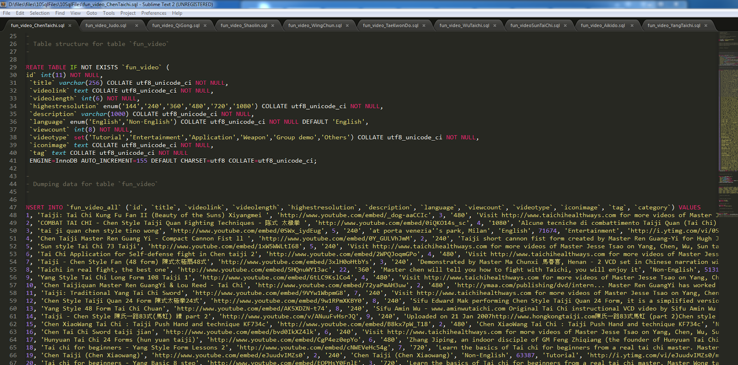

* From there, the find and replace function was used to change the id to id + #000, where # was equal to the number in the list of SQL files.
  + In this case, the original SQL insertion was in the form insert (col1, …,  col2) VALUES (c1, … ,c2), (c3, ... , c4) ....
  + This was changed to individual INSERT statements for each row in the table.

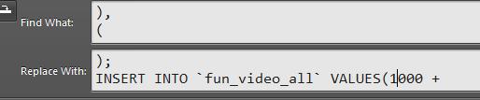

* + - CTRL + F, and then CTRL+H
  + For example:
    - Aikido was the first SQL file in the zip file, so the insert statement with ID 1 was changed to 1 + 1000.

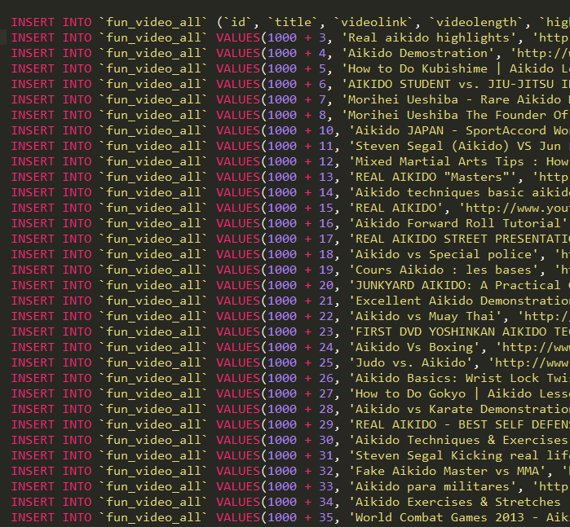

* + - The list of ranges is then:
      * Aikido 1001-1999
      * Chen Taichi 2001-2999
      * Judo 3001-3999
      * QiGong 4001-4999
      * Shaolin 5001-5999
      * Taekwondo 6001-6999
      * Wing Chun 7001-7999
      * Wu Taichi 8001-8999
      * Yang Taichi 9001-9999
      * Sun Taichi 10001-10999
* The end result was that each category on insertion was limited to a range from #001 to #999, where # was the number of the SQL file.



* Then, for each of the 10 SQL files, “, ‘<category name>)”’ replaced the end of the insert statement for each inserted video.
* Finally, each INSERT statement was copied and pasted into SQL editor from each of the 10 SQL files.
  + This created 1079 files.

# Cleaning and labeling of data

## Edited Movies

Upon opening each of the files There was a video with id, title and videolink (154, 'ttttti', '<http://www.youtube.com/v/urllllllll>') in Chen Taichi was obviously invalid, so the row was removed.

Also, a query was written to return all movies that had the tag ‘movie’ or movie in the title, and some files had their categories changed to KungFu Movie

**In Aikido:**

**Edited**(101, 'steven seagal aikido tribute')Moved to KungFu Movie

**In Shaolin:**

**Edited**(2, 'Alexander Lou in Guards of Shaolin [full movie]')Moved to KungFu Movie

**Edited**(8, 'Shaolin Ex Monk')Moved to KungFu Movie

**Edited**(9, 'Action Movies 2014 Full Movie | Shaolin Kids | Com')Moved to KungFu Movie

**Edited**(10, 'Shaolin Kickers - Best of Final')Moved to KungFu Movie

**Edited**(11, 'Shaolin Vs. Manchu (1984) - Kung Fu movie starring’)Moved to KungFu Movie

**Edited**(16, 'The Rebel Of Shaolin (1977)')Moved to KungFu Movie

**Edited**(21, 'American Shaolin German Full Movie')Moved to KungFu Movie

**Edited**(24, 'Shaolin Soccer - First Rounds of the Tournament - ')Moved to KungFu Movie

**Edited**(27, 'Shaolin Temple 4')Moved to KungFu Movie

**Edited**(32, 'Shaolin (Pelicula completa)')Moved to KungFu Movie

**Edited**(33, 'Shaolin Kung Fu Master')Moved to KungFu Movie

**Edited**(36, 'La Furia de Shaolín (Elton Chong, Eagle Han Ying)')Moved to KungFu Movie

**Edited**(37, 'The Shaolin Temple FULL MOVIE 1982 (Jet Li)')Moved to KungFu Movie

**Edited**(40, 'JET- Li Shaolin Temple ( Kids from Shaolin 1984) F')Moved to KungFu Movie

**Edited**(42, 'Shaolin Super Dragon (1982)')Moved to KungFu Movie

**Edited**(43, 'Shi Baohua in The Young Hero of Shaolin (1984) eng')Moved to KungFu Movie

**Edited**(45, '[1976]Shaolin Chamber Of Death')Moved to KungFu Movie

**Edited**(48, 'Shaw Brothers Kung Fu Shaolin Challenges Ninja')Moved to KungFu Movie

**Edited**(63, 'Chiang Sheng in Five Fighters from Shaolin [1982]')Moved to KungFu Movie

**Edited**(74, 'South Shaolin Vs. North Shaolin')Moved to KungFu Movie

**In Wu Taichi:**

**Edited**(1, 'Wudang KungFu-Sword Fight @SaltLake ,Utah, USA')Moved to KungFu Movie

**In Wing Chun:**

**Edited**(20, 'Ip Man ( Wing Chun ) - Final Fight')Moved to KungFu Movie

**Edited**(23, 'Bruce lee''s wing chun (high quality))Moved to KungFu Movie

**Edited**(28, 'Descendants of Wing Chun')Moved to KungFu Movie

**Edited**(34, 'Wing Chun Kung Fu vs. Karate’)Moved to KungFu Movie

**Edited**(42, 'Wing Chun')Moved to KungFu Movie

**Edited**(43, 'Orange County Wing Chun | The Legend is Born: Ip M') Moved to KungFu Movie

**Edited**(48, 'Karate Vs Wing Chun') Moved to KungFu Movie.

**Edited**(50, 'Ip Man Wing Chun Against 10 Karate Black Belts') Moved to KungFu Movie

**Edited**(56, 'Yip Man (Donnie Yen) vs Twister (Darren Shahlavi))Moved to KungFu Movie

**In Tae kwon do:**

**Edited**(2, 'Jeet Kune do vs Tae Kwon Do Ninjutsu')Moved to KungFu Movie

**In Judo:**

**Edited**(3, 'judo in movies')Moved to KungFu Movie

**Edited**(24, 'Mr Bean- Judo Class')Moved to KungFu Movie

**Edited**(217, 'Suicide Room - Judo Scene')Moved to KungFu Movie

# Video data input and modification

Show how your scripts allow admin to input and modify video data with narrated screenshots:

### First, Login with an admin account

* + [admin@email.com](mailto:admin@email.com)  with password adminpword1

apture.PNG

* Next, go to the home page and click Edit a Video!:



Then choose and edit a video

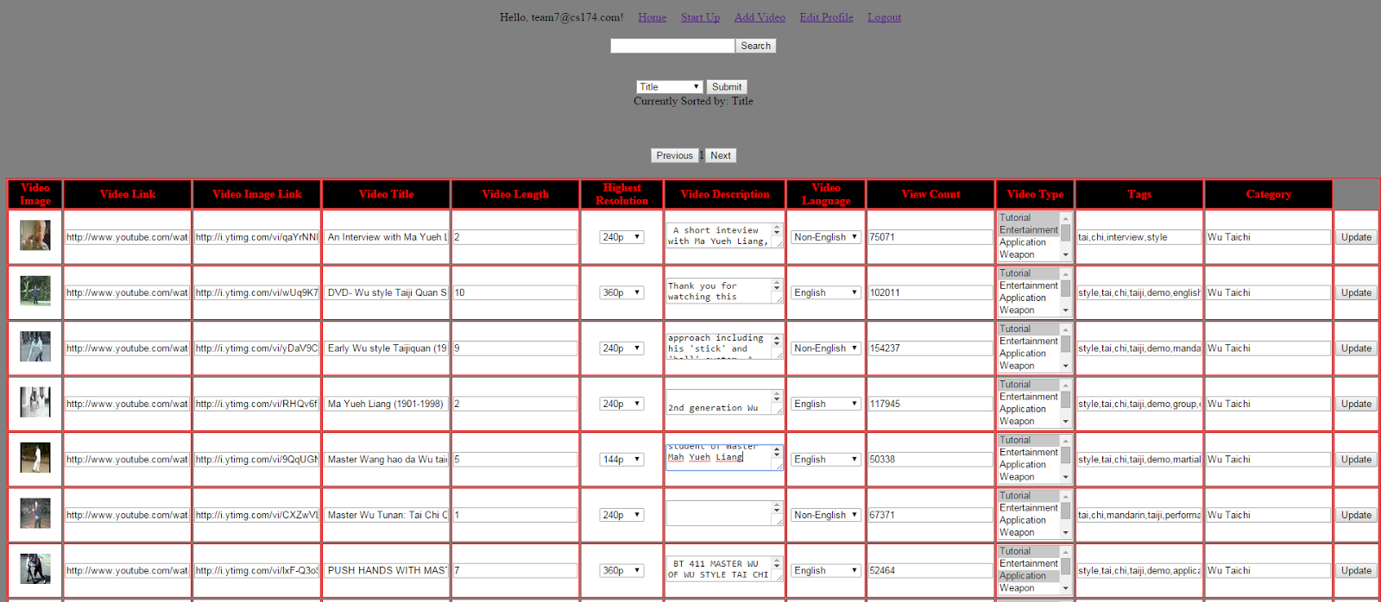

* After hitting update, this screen should show something like:



### 

### Login/Registration

### Registration password check

Describe in narrated screenshots how your password check work.

Show the the technical mechanism behind your password check.

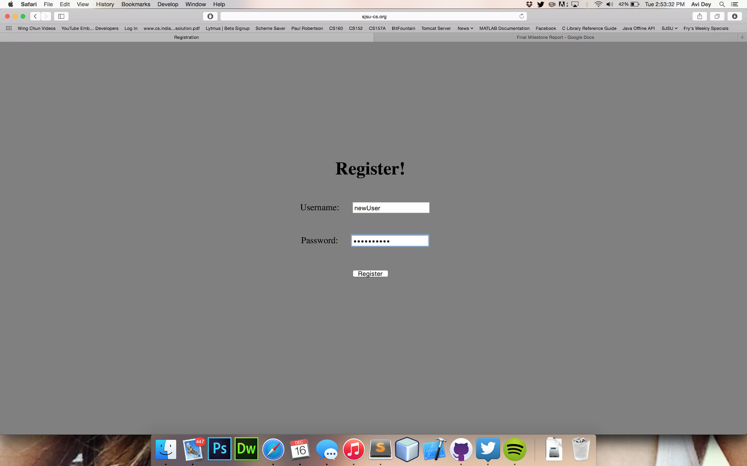

Above is a screenshot of the registration screen with sample data entered

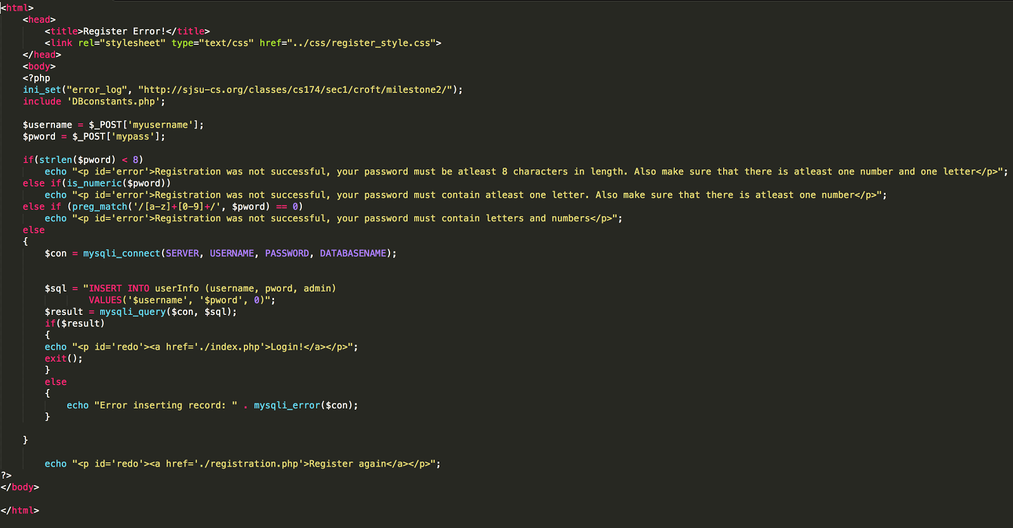

Above is the code found in register.php which grabs the post variables username and pword from the register html form and provides checks if the password follows the restriction of being longer than 8 characters, contains at least one number and one letter.

### Login and logout

### Show the workflow with narrated screenshots on your login and logout process here.https://lh3.googleusercontent.com/Wifn_zkhQ3xDvIyGWPnsmkd3opGHofyh9GpFm7w9B0H2oqa8OAH83QvCARpLw0sIHRciJRv2tkxZRdYZSo8bkMf3peFrDahtHrFuojE9vTjTGwRmHrBj5rH2V2tHPeilyQAbove is the homepage with a user account with proper credentials

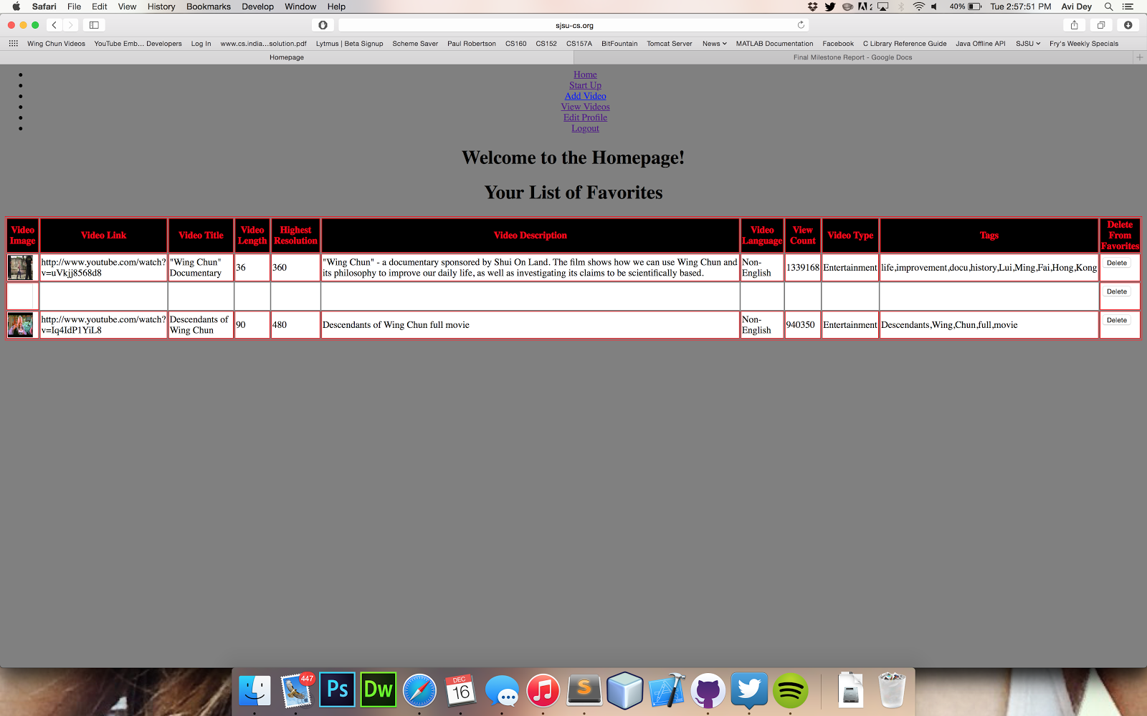

The screenshot above shows the user’s homepage screen after successfully logging into the system with proper credentials. It shows links the user can go to and a list of their favorite videos.

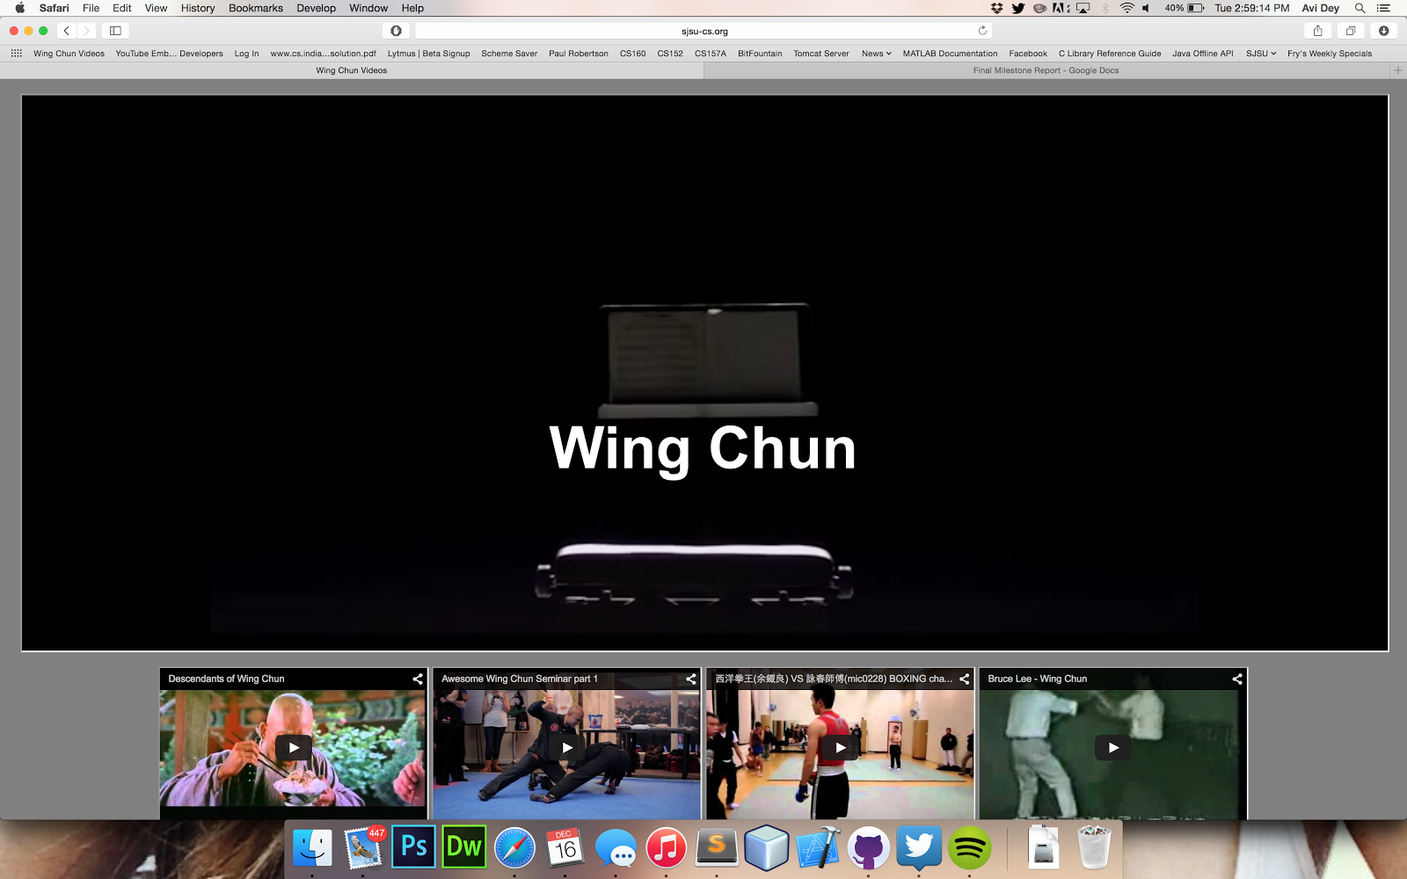

The screenshot above shows what happens when the user clicks logout from their homescreen. It redirects them to the pain startup page.

## Startup page

How your startup page design look like and show what is what on screenshot with matching narration.

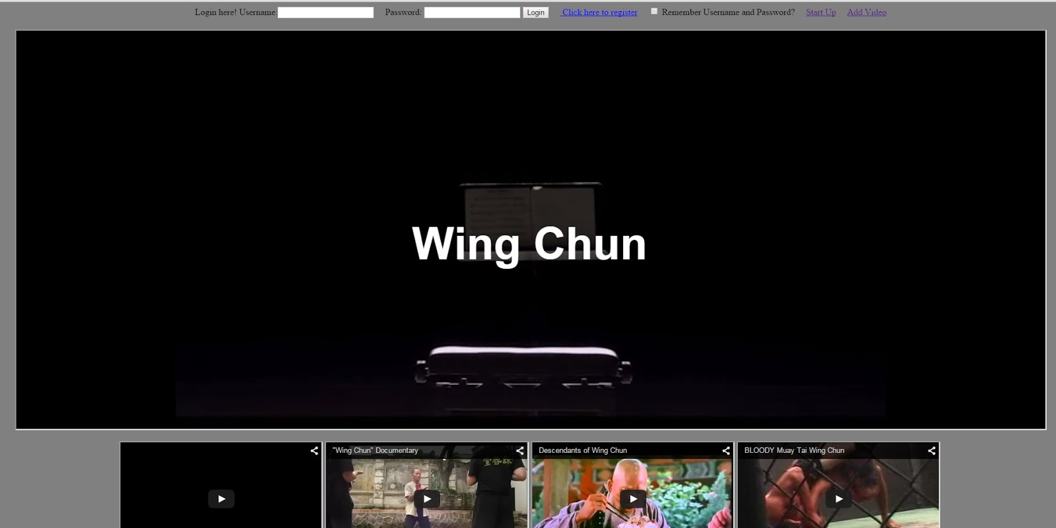

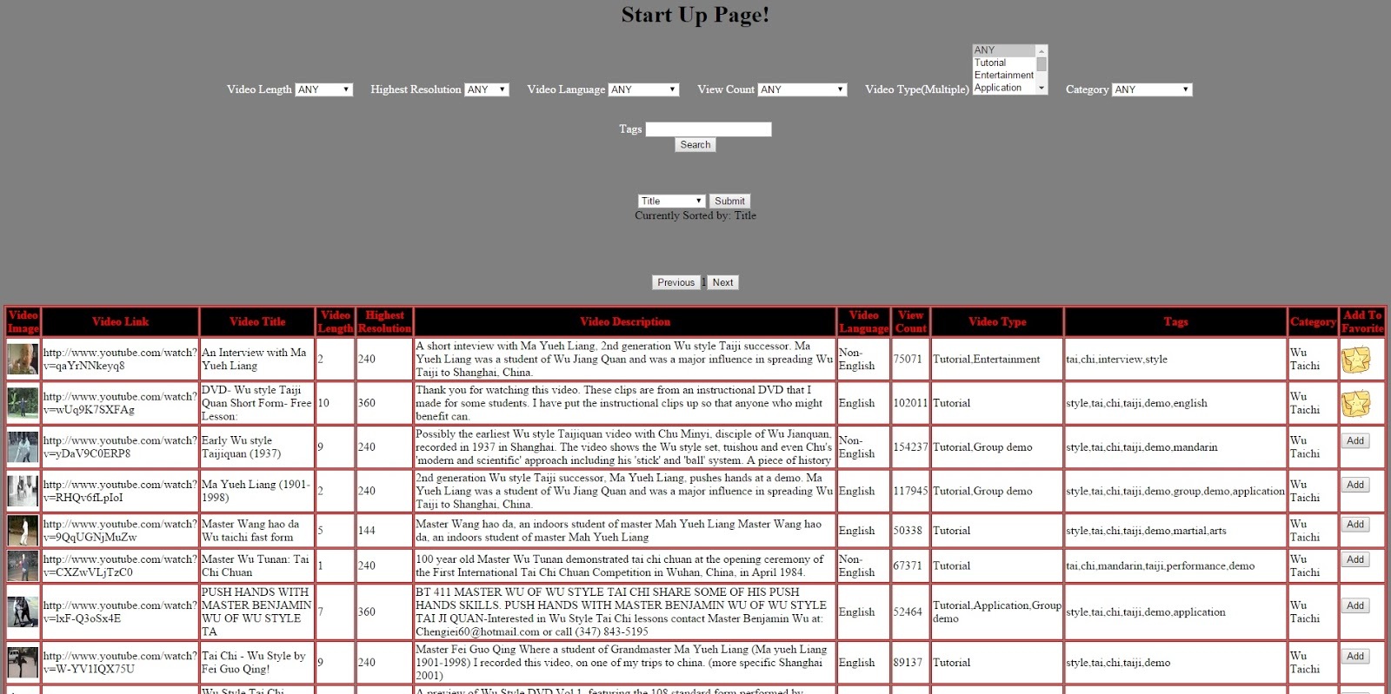

At the very top is the login/registration.

The user gains access to the next level of menu items after logging in. The next thing on the screen is the full screen video player.

Lastly as you scroll down the startup page, there is the list of videos, where the user can search through and filter videos.

### Favorite/recommended videos

Show a screenshot on how a row of icon images display recommended videos or favorite videos when logged in. Describe technically how you accomplished this.

Did not complete. Favorite videos were able to be shown only as a table relation. Thumbnails were not shown as seen below.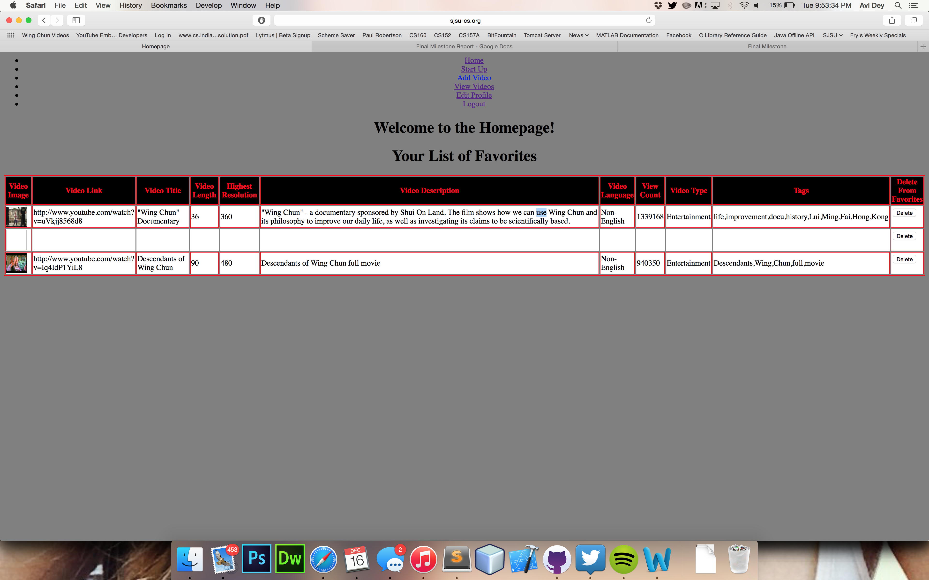

### 

### 

### Video search

Our search box is on the index.php or search.php and works by checking if the inputted value is matched in a tag. So if a movie has a tag KungFu movie, a search of ‘movie’ will pick up that movie. This is accomplished by appending [ tag LIKE ‘%$search%’] to the end of a select all statement, getting the $search value from the text input element. To limit to specific ranges, the select boxes were created to give the user a choice of ranges to choose from.



### The values of the select boxes are numeric, however each are named after the type field that will limit the search. The numeric values are used as keys to map to the specific values shown. For example, the select box for Video Length has values 0-5min, 5-10min, 10-30min, 30-60min and 60+. These are matched in term to 0, 1, 2, 3, 4. These are then matched to an array that looks like this

Array(

0=> “ AND videolength <= 5”,

1=> “ AND videolength <= 10 AND videolength >= 5”,

2=> “ AND videolength <= 30 AND videolength >= 10”,

3=> “ AND videolength <= 60 AND videolength >= 30”,

4=> “ AND videolength >= 60”

)

The rest of the categories use similar arrays with similar keys.

### 

### Browse by selected category

The category limiter is located in the same area as the search, it is on the right end of the search



Simply by setting the category and then pressing search, the only results that show will be of the specific chosen category. The category also uses an array with keys and values to reference what to query the database for.

## 

## Favorite videos

### Selecting favorite videos

Show your workflow of how logged in users can select favorite videos and technically how you accomplished this.

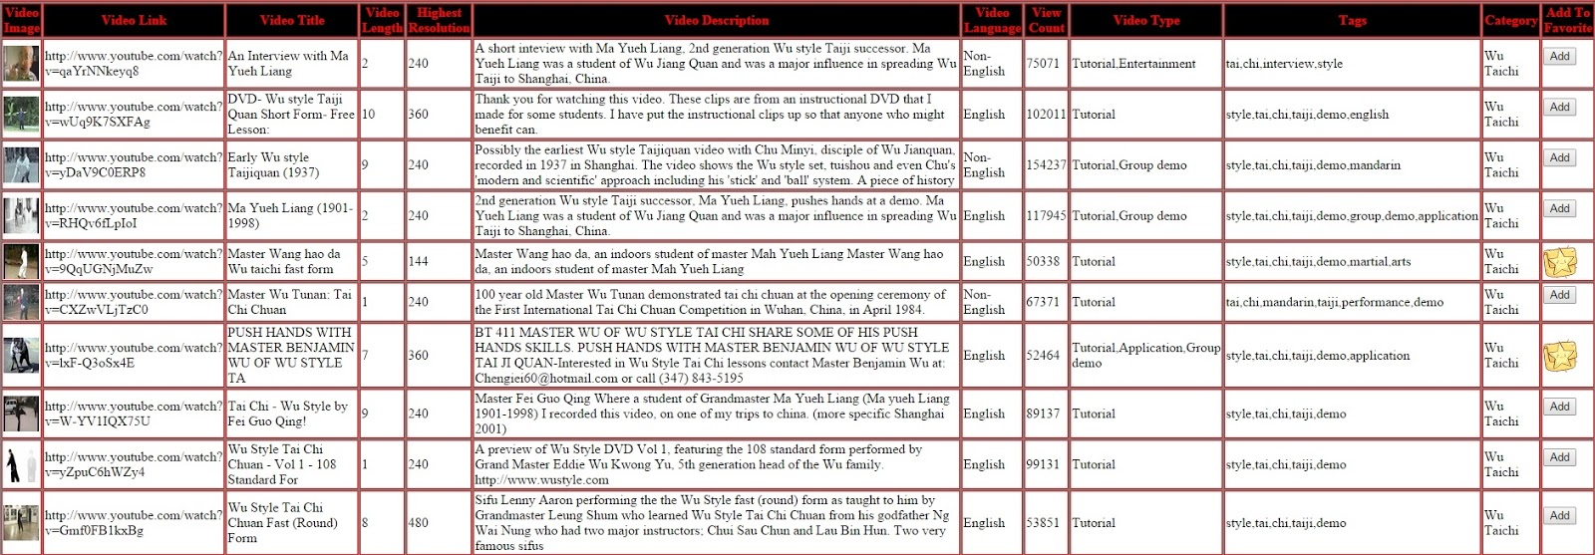

The user can add a favorite video by going to the startup page and going to the list of videos and then clicking the “Add” button in the Add To Favorites column in the table.

We handled this aspect technically by utilizing session variables.

### 

Deselect favorite videos

Show how logged in users can deselect favorite videos with a workflow of narrated screenshots.

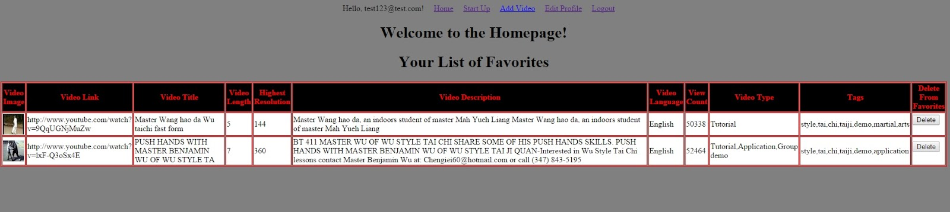

To remove a favorite, the user simply has to click the “Delete” button in the Delete From Favorites Column shown in the screenshot.

### 

### Testing with web browsers

Show with matching screenshots how your work looks like under Firefox and Chrome (indicate versions) as hosted under instructor (not yours) server.

Chrome Version 39.0.2171.95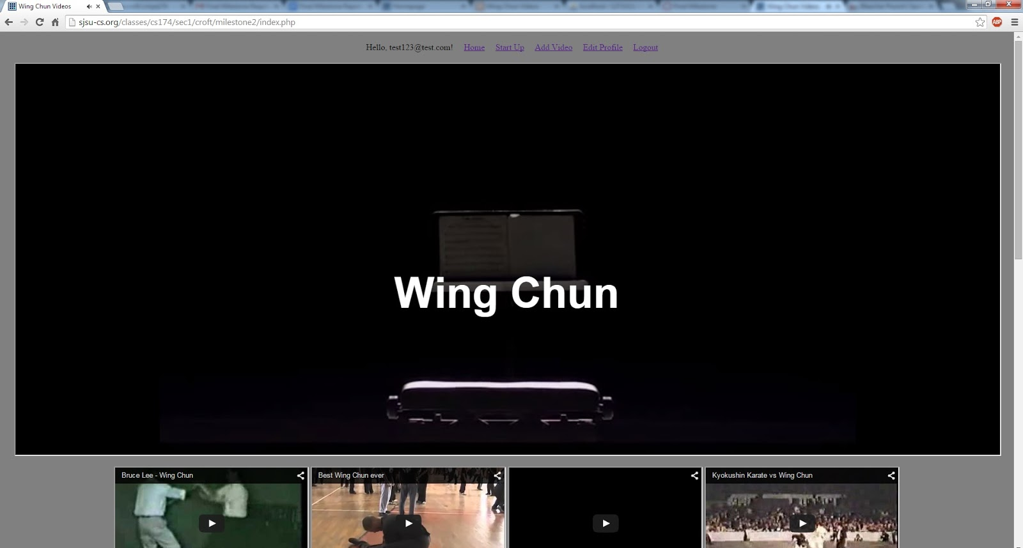

Firefox Version 31.0

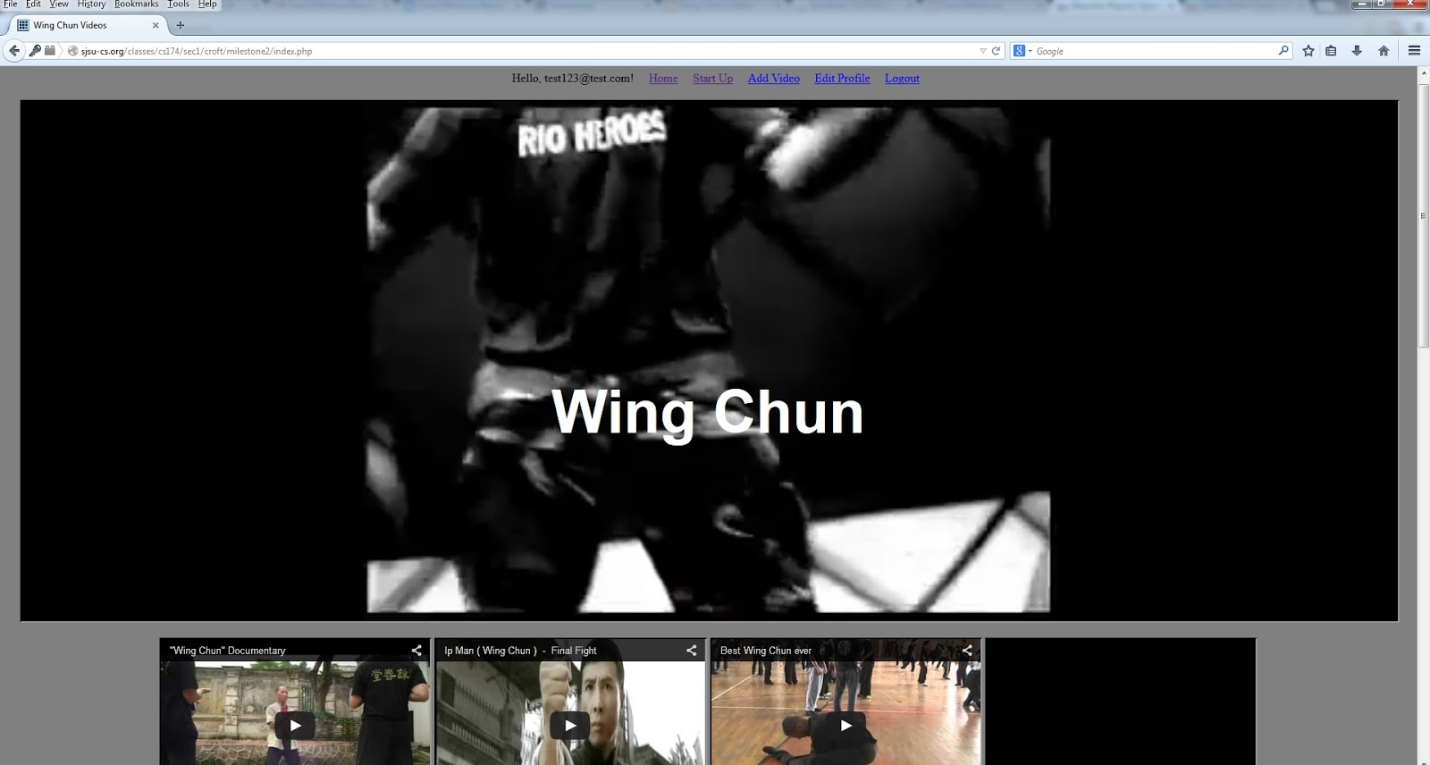

### Bonus Feature

## Chinese Kung Fu Movie Youtube videos

We have added 6 Full-length Kung Fu Videos with minimum 720p, and over 50,000 views. The link to the page that shows these videos is on the index.php page here:

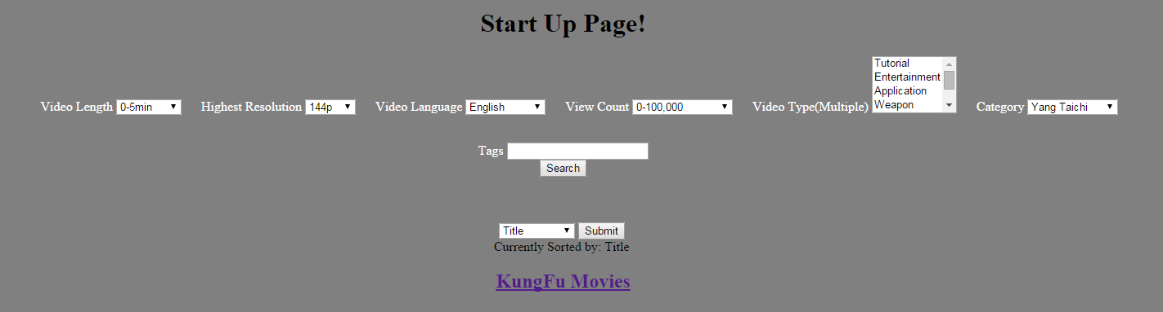

1.     Once Upon A Time In China 3

:<https://www.youtube.com/watch?v=IoqeigEzw7w> 720p, 117100 view counts

2.     …La Furia de Shaolín (Elton Chong, Eagle Han Ying)(The Fury of Shaolin)

<http://www.youtube.com/watch?v=GiMUYI8fjy0> 720p, 677162 views

3.     New Action Movies 2014 Full Movie | New Movies 2014 | Chinese Martial Arts Movies 2014(The Four 2)

<https://www.youtube.com/watch?v=RbilL8-HxFA> 1080p, 2089811 views

# **4. Best Action Movies | Nicholas Tse Full HD Movies English Subtitles | Chinese Martial Art (Treasure Inn)**

<https://www.youtube.com/watch?v=Z3YagJsXzHk>, 720p, 872267 Views

# **5.  Best Action Movies | Donnie Yen | The Lost Bladesman HD English Subtitles(The Lost Bladesman)**

<https://www.youtube.com/watch?v=xR-EIfMHjBQ>, 720p, 81320 views

# **6. ACTION MOVIES 2014 - DONNIE YEN | THE SW0RDSMEN 3D - BEST KUNGFU FULL HD English Subtitle(Dragon - Wu Xia)**

<https://www.youtube.com/watch?v=b2lZV7IazDw>, 720p, 366462 views